SYNOPSIS

Online Library Management System is a system which maintains the information about the books present in the library, their authors, the members of library to whom books are issued, library staff and all. This is very difficult to organize manually. Maintenance of all this information manually is a very complex task. Owing to the advancement of technology, organization of an Online Library becomes much simple. The Online Library Management has been designed to computerize and automate the operations performed over the information about the members, book issues and returns and all other operations. This computerization of library helps in many instances of its maintenances. It reduces the workload of management as most of the manual work done is reduced. The daily manual process of the **“Libraries”** like Book entry details, Students and Staffs entry details, Book purchase entry details, Book transaction, and Fine Days Details etc. had been implemented which can be followed through the computer technology i.e., **“Library Management”**

.

CHAPTER-1

INTRODUCTION

* 1. INTRODUCTION

This Project is entitled as “ONLINE LIBRARY MANAGEMENT”, PHP as a Front End Tool and MYSQL Server as a Back end Tool. Library management system is a project which aims in developing a computerized system to maintain all the daily work of library .This project has many features which are generally not available in normal library management systems like facility of user login and a facility of teachers login .It also has a facility of admin login through which the admin can monitor the whole system .It also has facility of an online notice board where teachers can student can put up information about workshops or seminars being held in our colleges or nearby colleges and librarian after proper verification from the concerned institution organizing the seminar can add it to the notice board . It has also a facility where student after logging in their accounts can see list of books issued and its issue date and return date and also the students can request the librarian to add new books by filling the book request form. The librarian after logging into his account ie admin account can generate various reports such as student report , issue report, teacher report and book report Overall this project of ours is being developed to help the students as well as staff of library to maintain the library in the best way possible and also reduce the human efforts.

.

CHAPTER-2

SYSTEM ANALYSIS

* 1. **EXISTING SYSTEM**

In the existing system the sales alone is maintained in FoxPro. The book details, the issue details and the return details are maintained manually. The study of the existing system revealed that the system has several drawbacks.

**DRAWBACKS OF EXISTING SYSTEM**

* The existing system has no security measure against logging in and no checks are made for authorized users.
* The end user has to remember a lot of command to make efficient use of the system.
* The system does not have any descriptive reports and thus did not help management in decision-making.
* The sales information per day is unable to find.
* Enormous amount of time is consumed.

**PROPOSED SYSTEM**

The proposed system is been developed to maintain the library management by the librarian to maintain the books details, members details, sales details, issue details, return details etc.

**The Advantages of proposed system**

* The user can enter only if the username and the password are correct.
* The process of planning will be easy since every process is computerized.
* Time Saving.
* The Sales information per day and per month can be known.
* The details of the all saved information can be viewed.
* The data can be accessed easily whenever needed and so the manual work can be reduced.
* Reduced paper work.

**2.3 FEASIBILITY STUDY**

The feasibility of the project is analyzed in this phase and business proposal is put forth with a very general plan for the project and some cost estimates. During system analysis the feasibility study of the proposed system is to be carried out. This is to ensure that the proposed system is not a burden to the company. For feasibility analysis, some understanding of the major requirements for the system is essential.

Three key considerations involved in the feasibility analysis are

* ECONOMICAL FEASIBILITY
* TECHNICAL FEASIBILITY
* OPERATIONAL FEASIBILITY

**2.3.1 ECONOMICAL FEASIBILITY**

This study is carried out to check the economic impact that the system will have on the organization. The amount of fund that the company can pour into the research and development of the system is limited. The expenditures must be justified. Thus the developed system as well within the budget and this was achieved because most of the technologies used are freely available. Only the customized products had to be purchased.

### 2.3.2 TECHNICAL FEASIBILITY

This study is carried out to check the technical feasibility, that is, the technical requirements of the system. Any system developed must not have a high demand on the available technical resources. This will lead to high demands on the available technical resources. This will lead to high demands being placed on the client. The developed system must have a modest requirement, as only minimal or null changes are required for implementing this system.

**2.3.3 OPERATIONAL FEASIBILITY**

The aspect of study is to check the level of acceptance of the system by the user. This includes the process of training the user to use the system efficiently. The user must not feel threatened by the system, instead must accept it as a necessity. The level of acceptance by the users solely depends on the methods that are employed to educate the user about the system and to make him familiar with it. His level of confidence must be raised so that he is also able to make some constructive criticism, which is welcomed, as he is the final user of the system.

CHAPTER-3

SYSTEM SPECIFICATION

**3.1 HARDWARE SPECIFICATION**

1. **1.2.1 HARDWARE SPECIFICATION**
2. **Server**
3. Platform : Windows 8
4. System : dual core
5. Ram : 4GB
6. Hard disk : 500GB
7. **Client**
8. Platform : Windows 8
9. System : dual core
10. Ram : 4GB
11. Hard disk : 500GB

**3.2 SOFTWARE SPECIFICATION**

Web server : XAMPP Server

Back end : MYSQL

Server side scripting : PHP

Client side scripting : HTML

Designing Tools : Dreamweaver

1. **3.3 SOFTWARE DESCRIPTION**

**CLIENT/SERVER ENVIRONMENT:**

To design and develop the **“ONLINE LIBRARY MANAGEMENT SYSTEM”**, it is essential to understand the client/server model that plays an important role in the concern, which needs the information to be retrieved in a fast and efficient way.

**What is Client/Server?**

The Client/Server computing model implies a form of processing when requests are submitted by a client or requests the server which processes them and returns the result to the client. The client and the server are two separate logical entities working together over a network to accomplish the task.

Conceptually, the client server architecture can be defined as a special case of Co-operative processing where on entire application is shared between the client and a server system.

## Features of client/server computing

* Improved access to information due to internet
* Globalization of information
* Easier maintenance of application and data
* Graphically oriented, high interactive user interface
* Increased developer productivity through ease of tools

In our project we have divided core part into two parts. Asp pages, html pages are used as user interface (client). They gather the information from the user and process them. Ms.Access is stored in IIS, which is used as server.

**Installation requirements**

When installing web development to a hard drive other than ordinary PC, one need to have at least 65-70MB free space on a drive to precede installation, regardless of how much space is on installation drive.

**Operating system: Windows 8**

**Web server : All OS Apache,Mysql,Php,Perl (XAMPP)**

**NETWORK SPECIFICATION**

**Network Card : Ethernet card**

**Operating system : Windows XP**

**Communication protocol: TCP/IP, HTTP**

**Connection Type : LAN**

**XP PLATFORM:**

XP is a powerful multitasking operating system with high security. It is user friendly and supports multithreading and lot of tools for developing in any application. This OS has number of enhancements, including performance improvement, better hardware support and closer integration with the Internet. Windows support dynamic linking. This OS has the concept of plug and play.

**WEB SERVER:**

The Web server accepts the request and sends the HTML to the Client browser that requests it. Web browser and web server communicate through a common protocol (HTTP). The examples for web server are XAMPP(any of four different operating systems,**A**pache,**M**ySQL,**P**hp,**P**erl),WAMP(**W**indows,**A**pache,**M**ySQL,**P**hp),MAMP(**M**acintosh, **A**pache, **M**ySQL, **P**HP).

**PHP**

PHP stands for Hypertext Preprocessor. PHP scripts run inside Apache server or Microsoft IIS. PHP and Apache server are free. PHP code is very easy. PHP is the most used server side scripting language. PHP files contain PHP scripts and HTML. PHP files have the extension “php”, “php3”, “php4”, or “phtml”.

1. **Using PHP**

* Generate dynamic web pages. PHP can display different content to different user or display different content at different times of the day.
* Process the contents of HTML forms. We can use a PHP to retrieve and respond to the data entered into an HTML form.
* Can create database-driven web pages. A PHP can insert new data or retrieve existing data from a database such a MySQL.

1. **Working of PHP**

PHP is a standard HTML file that is extended with additional features. Like a standard HTML file, PHP contains HTML tag that can be interpreted and displayed by a web browser. Anything we could normally place in an HTML file Java applets, Blinking text, server side scripts .we can place in PHP. However, PHP has three important features that make it unique.

* PHP contains server side scripts.
* PHP provides several built-in objects.

**HYPER TEXT MARKUP LANGUAGE (HTML)**

HTML is an application of the Standard Generalized Markup Language (SGML), which was approved as an international standard in the year 1986. SGML provides a way to encode hyper documents so they can be interchanged.

SGML is also a Meta language for formally describing document markup system. Infact HTML uses SGML to define a language that describes a WWW hyper document’s structure and inter connectivity.

Following the rigors of SGML, TBL bore HTML to the world in 1990. Since then, many of us have it to be easy to use but sometimes quite limiting. These limiting factors are being addressed but the World Wide Web Consortium (aka W3c) at MIT. But HTML had to start somewhere, and its success argues that it didn’t start out too badly.

**MYSQL**

MySQL Server is a powerful database management system and the user can create application that requires little or no programming. It supports GUI features and an entire programming language, Phpmyadmin which can be used to develop richer and more developed application. There are quite a few reasons, the first being that MySQL is a feature rich program that can handle any database related task you have. You can create places to store your data build tools that make it easy to read and modify your database contents, and ask questions of your data. MySQL is a relational database, a database that stores information about related objects. In MySQL that database means a collection of tables that hold data. It collectively stores all the other related objects such as queries, forms and reports that are used to implement function effectively.

The MySQL database can act as a back end database for PHP as a front end, MySQL supports the user with its powerful database management functions. A beginner can create his/her own database very simply by some mouse clicks. Another good reason to use MySQL as back end tool is that it is a component of the overwhelmingly popular Open source software.

**Database:**

A database is simply a collection of used data just like phone book. MySQL database include such objects as tables, queries, forms, and more.

**Tables:**

In MySQL tables are collection of similar data. With all tables can be organized differently, and contain mostly different information- but they should all be in the same database file. For instance we may have a database file called video store. Containing tables named members, tapes, reservations and so on. These tables are stored in the same database file because they are often used together to create reports to help to fill out on screen forms.

**Relational database:**

MySQL is a relational database. Relational databases tools like access can help us manage information in three important ways.

* Reduce redundancy
* Facilitate the sharing of information
* Keep data accurate.

###### **Fields**

###### Fields are places in a table where we store individual chunks of information.

**Primary key and other indexed fields:**

MySQL use key fields and indexing to help speed many database operations. We can tell MySQL, which should be key fields, or MySQL can assign them automatically.

**Controls and objects:**

Queries are access objects us display, print and use our data. They can be things like field labels that we drag around when designing reports. Or they can be pictures, or titles for reports, or boxes containing the results of calculations.

# Queries and dynasts:

Queries are request to information. When access responds with its list of data, that response constitutes a dynaset. A dynamic set of data meeting our query criteria. Because of the way access is designed, dynasts are updated even after we have made our query.

**Forms:**

Forms are on screen arrangement that make it easy to enter and read data. we can also print the forms if we want to. We can design form our self, or let the access auto form feature.

**Reports:**

Reports are paper copies of dynaset. We can also print reports to disk, if we like. Access helps us to create the reports. There are even wizards for complex printouts.

**Properties:**

Properties are the specification we assigned to parts of our database design. We can define properties for fields, forms, controls and most other access objects.

# COST ESTIMATION AND SCHEDULING

For developing the software and hardware requirements needed the less cost of developing the software package takes five months duration.

**DEVELOPMENT SPECIFICATION**

This includes salaries and other employment costs of the staff involved in the development project and all associated costs.

* **Setup cost:**

This includes the cost of putting the system into place. These consists mainly of the cost of any new hardware and ancillary equipment but will also include cost of file conversion, recruitment and staff training.

* **Operational cost:**

It consists of cost of operating the system once it has been installed.

Benefits on the other hand, or often quite difficult to quantify in monetary terms even once thus have been identified.

###### Development cost

Development cost includes salaries and other employment costs of the staff involved in the development project and all associated costs

Benefits may be categorized as follows:

* Direct benefits
* Accessible indirect benefits
* Intangible benefits

**Direct benefits:**

These accrue directly from the operation of the proposed system. These could for example: include reduction in salary bills through introduction of a new, computerized system.

**Accessible indirect benefits:**

These are generally secondary benefits such as increased accuracy through the introduction of a user-friendlier screen design where we might be able to estimate the reduction error and hence cost of proposed system.

# Intangible benefits

These are generally longer term or benefit that are considered very difficult to qualify. Enhanced job interest can lead to reduced staff turnover and hence lower recruitment

#### CHAPTER-4

#### SYSTEM DESIGN

**4.1 INPUT DESIGN**

Input design is one of the most important phases of the system design. Input design is the process where the input received in the system are planned and designed, so as to get necessary information from the user, eliminating the information that is not required. The aim of the input design is to ensure the maximum possible levels of accuracy and also ensures that the input is accessible that understood by the user.

The input design is the part of overall system design, which requires very careful attention. If the data going into the system is incorrect then the processing and output will magnify the errors.

The objectives considered during input design are :

* Nature of input processing.
* Flexibility and thoroughness of validation rules.
* Handling of properties within the input documents.
* Screen design to ensure accuracy and efficiency of the input relationship with files.
* Careful design of the input also involves attention to error handling, controls, batching and validation procedures.

Input design features can ensure the reliability of the system and produce result from accurate data or they can result in the production of erroneous information.

**4.2 DATABASE DESIGN**

Database design is required to manage the larger bodies of information. The management of data involves both the definition of structure of the storage of information and provisions of mechanism for the manipulation of information. In addition, the database system must provide for the safety of information handled, despite the system crashed due to attempts and unauthorized access. Database design phase involves the design of database and its consistent tables are used by the applications for storage and retrieval of data. The system uses SQL Server as backend database management system, which allows the data to be protected and organized separately from other resources.

For developing an efficient database, the conditions to be fulfilled are:

* Control redundancy
* Ease of use
* Data Independence
* Accuracy and Integrity
* Avoiding inordinate delays
* Recovery from failure
* Privacy and security
* Performance

**4.3OUTPUT DESIGN**

Computer output is the most important and direct source of information to the user. Efficient, intelligible output design should improve the system’s relationships with the user and help in decision making. A major form of output is the hard copy from the printer. The output devices to consider depend on factors such as compatibility of the device with the system, response time requirements, expected print quality and number of copies needed. . All nodes in the network may depart or fail unpredictably.

The partition the continuously generated measurement data by time slots, where a source block refers to the amount of the data generated in one time slot on a node. Clearly, how many time slots of data can be cached depends on the size of the node cache storage.

A synchronization packet (commonly known as the timing reference signal) occurs immediately before the first active sample on every line, and immediately after the last active sample (and before the start of the horizontal blanking region).A systems flowchart specifies master files, transaction files and computer programs. Input Data are collected and organized into groups of similar data. Once identified, appropriate input media are selected for processing. The output devices to consider depend on factors such as compatibility of the device with the system, response time requirements, expected print quality and number of copies needed. . All nodes in the network may depart or fail unpredictably.

**4.4 MODULE DESCRIPTION**

* **In this project, we use PHP and My SQL database. It has two module**The project consists of six modules as follows:
  + Members Details
  + Book Entry
  + Sales Details
  + Issue Details
  + Return Details

**Members Details:**

It contains all Members of library details such as name, address, membership amount etc.

**Book Entry:**

It contains all book details of library maintenance such as book id, book name, author name, publisher, rate etc.

**Sales Details:**

It contains all sales details of members.

**Issue Details:**

It contains all issues of books details of library management

**Return Details:**

It contains all books return details of library management

**CHAPTER-5**

**SYSTEM TESTING AND IMPLEMENTATION**

**5.1 TESTING**

Testing is a series of different tests that whose primary purpose is to fully exercise the computer based system. Although each test has a different purpose, all work should verify that all system element have been properly integrated and performed allocated function. Testing is the process of checking whether the developed system works according to the actual requirement and objectives of the system.

The philosophy behind testing is to find the errors. A good test is one that has a high probability of finding an undiscovered error. A successful test is one that uncovers the undiscovered error. Test cases are devised with this purpose in mind. A test case is a set of data that the system will process as an input. However the data are created with the intent of determining whether the system will process them correctly without any errors to produce the required output.

**TYPES OF TESTING:**

* Unit testing
* Integration testing
* Validation testing
* Output testing
* User acceptance testing

**UNIT TESTING:**

All modules were tested and individually as soon as they were completed and were checked for their correct functionality.

**INTEGRATION TESTING**

The entire project was split into small program; each of this single programs gives a frame as an output. These programs were tested individually; at last all these programs where combined together by creating another program where all these constructors were used. It give a lot of problem by not functioning is an integrated manner.

The user interface testing is important since the user has to declare that the arrangements made in frames are convenient and it is satisfied. When the frames where given for the test, the end user gave suggestion. Based on their suggestions the frames where modified and put into practice.

# VALIDATION TESTING

At the culmination of the black box testing software is completely assembled as a package. Interfacing errors have been uncovered and corrected and a final series of test i.e., Validation succeeds when the software function in a manner that can be reasonably Accepted by the customer.

**OUTPUT TESTING**

After performing the validation testing the next step is output testing of the proposed system. Since the system cannot be useful if it does not produce the required output. Asking the user about the format in which the system is required tests the output displayed or generated by the system under consideration. Here the output format is considered in two ways. one is on screen and another one is printed format. The output format on the screen is found to be corrected as the format was designed in the system phase according to the user needs. And for the hardcopy the output comes according to the specifications requested by the user.

**USER ACCEPTANCE SYSTEM**

An acceptance test as the objective of selling the user on validity and reliability of the system. It verifies that the procedures operate to system specification and mat the integrity of vital is maintained.

**PERFORMANCE TESTING**

This project is a application based project, and the modules are interdependent with the other modules, so the testing cannot be done module by module. So the unit testing is not possible in the case of this driver. So this system is checked only with their performance to check their quality.

**5.2 IMPLEMENTATION**

System implementation is stage in the project where the theoretical design is turned into the working system. The most crucial stage is giving the users confidence that the new system will work effectively and efficiently.

The performance of reliability of the system is tested and it gained acceptance. The system was implemented successfully. Implementation is a process that means converting a new system in to operation.

Proper implementation is essential to provide a reliable system to meet organization requirements. During the implementation stage a live demon was undertaken and made in front of end-users. The various features provided in the system were discussed during implementation.

**CHAPTER-6**

**CONCLUSION**

The “**ONLINE LIBRARY MANAGEMENT SYSTEM**” has been developed to satisfy all proposed requirements... The system is highly scalable and user friendly. Almost all the system objectives have been met. The system has been tested under all criteria. The system minimizes the problem arising in the existing manual system and it eliminates the human errors to zero level. The design of the database is flexible ensuring that the system can be implemented. It is implemented and gone through all validation.

All phases of development were conceived using methodologies. User with little training can get the required report. The software executes successfully by fulfilling the objectives of the project. Further extensions to this system can be made required with minor modifications.

**BIBLIOGRAPHY**

PHP/MYSQL MYSQL REFERENCE SITES

<http://www.w3schools.com>

<http://www.tuxradar.com/practicalphp>

<http://phpbuddy.com/index.php>

[http://www.daniweb.com](http://www.daniweb.com/)

[http://www.pscode.com](http://www.pscode.com/)

[http://dev.mysql.com](http://dev.mysql.com/)

<http://www.mysqltutorial.org/>

[www.hotscripts.com](http://www.hotscripts.com/)

[www.freesoft.in](http://www.freesoft.in/)

PHP/MYSQL REFERENCE BOOKS

1. Beginning PHP 5.3 **- Matt Doyle** Publication, first Edition, (October 26, 2009).
2. Expert PHP and MySQL - **Andrew Curioso, Ronald Bradford, Patrick Galbraith** Publication, Fourth Edition,2010
3. Beginning Php and Mysql **–W.Jason Gilmore** Publication, Fourth Edition,2010

|  |  |
| --- | --- |
|  |  |

1. PHP and MySQL 24-Hour Trainer - **Andrea Tarr** Publication, Second Edition,2011
2. Web Database Applications with PHP & MySQL, - [Hugh E. Williams](http://www.amazon.com/Hugh-E.-Williams/e/B001IGLN0Q/ref=ntt_athr_dp_pel_1) (Author), [David Lane](http://www.amazon.com/David-Lane/e/B001IGFLCC/ref=ntt_athr_dp_pel_2) Publication, Second Edition,2009

**APPENDICES**

1. **SOURCE CODE**

<?php

session_start();

include_once "../db/db.php";

?>

<!DOCTYPE html PUBLIC "-//W3C//DTD XHTML 1.0 Transitional//EN" "http://www.w3.org/TR/xhtml1/DTD/xhtml1-transitional.dtd">

<html xmlns="http://www.w3.org/1999/xhtml">

<head>

<meta http-equiv="Content-Type" content="text/html; charset=utf-8" />

<title><?php include('../title.php') ?></title>

<link href="../css/style.css" rel="stylesheet" type="text/css" />

</head>

<body>

<div class="total">

<table width="100%" border="0" cellpadding="0" cellspacing="0" style="background:url(../images/banner.png) no-repeat bottom">

<tr>

<td height="260" align="center" valign="top"><span style="float:left;line-height:60px;font-weight:bold;padding-left:25px;"><?php echo $_SESSION['user_name']; ?> logged in...</span><span class="menu"><?php include('menu.php') ?> </span></td>

</tr>

</table>

<table width="100%" border="0" style="border-top:#FFFFFF solid 3px;" cellpadding="0" cellspacing="0">

<tr>

<td colspan="4">&nbsp;</td>

</tr>

<tr>

<td height="53" colspan="4" align="center"><h1>VIEW BOOKS</h1></td>

</tr>

<tr>

<td colspan="4">&nbsp;</td>

</tr>

<tr>

<td width="1%" height="55" align="center">&nbsp;</td>

<td width="98%" align="center" bgcolor="#FFFFFF" style="color:#000000;font-size:14px;font-weight:bold">

<table width="100%" border="1">

<tr style="color:#FFFFFF;background-color:#333333">

<td width="21%" height="37" align="center"><strong>Department</strong></td>

<td width="17%" align="center"><strong>Title</strong></td>

<td width="8%" align="center"><strong>Author</strong></td>

<td width="9%" align="center"><strong>Volume</strong></td>

<td width="14%" align="center"><strong>Publications</strong></td>

<td width="10%" align="center"><strong>Issue<br />

Date</strong></td>

<td width="9%" align="center"><strong>Return<br />

Date</strong></td>

<td width="12%" align="center"><strong>Action</strong></td>

</tr>

<?php

$sel = "select * from tender where ten_status = 'Published' order by ten_id desc";

$from = mysql_query($sel);

while($res=mysql_fetch_object($from))

{

?>

<tr>

<td height="43" align="center"><strong><?php echo $res->ten_title; ?></strong></td>

<td align="center"><strong><?php echo $res->ten_dept; ?></strong></td>

<td align="center"><strong><?php echo $res->ten_type; ?></strong></td>

<td align="center"><strong><?php echo $res->ten_value; ?></strong></td>

<td align="center"><strong><?php echo $res->ten_loc; ?></strong></td>

<td align="center"><strong><?php echo $res->ten_odate; ?></strong></td>

<td align="center"><strong><?php echo $res->ten_cdate; ?></strong></td>

<td align="center">

<?php

$sels = "select * from application where app_sup = '".$_SESSION['user_id']."' AND app_ten = '".$res->ten_id."'";

$froms = mysql_query($sels);

$ress=mysql_fetch_object($froms);

if($ress > 0)

{

echo "Applied";

}

else

{

?>

<a href="apply.php?ten_id=<?php echo $res->ten_id; ?>" style="text-decoration:none">

<input type="button" value="Book" style="width:50px"/></a>

<?php } ?>

</td>

</tr>

<?php } ?>

</table>

</td>

<td width="1%" align="center">&nbsp;</td>

</tr>

<tr>

<td colspan="4">&nbsp;</td>

</tr>

<tr>

<td colspan="4">&nbsp;</td>

</tr>

<tr>

<td colspan="4">&nbsp;</td>

</tr>

</table>

</form>

<table width="100%" border="0" class="table2">

<tr>

<td height="60" align="center"><?php include('../footer.php') ?></td>

</tr>

</table>

</div>

</body>

</html>

<?php

session_start();

include_once "../db/db.php";

if($_REQUEST['Mode']=='Edit')

{

$sel="select * from `tender` where ten_id = '".$_REQUEST['ten_id']."'";

$from=mysql_query($sel);

$res=mysql_fetch_object($from);

}

if($_REQUEST['Mode']=='Delete')

{

$sql = "DELETE FROM `tender` WHERE `ten_id` = '".$_REQUEST['ten_id']."'";

mysql_query($sql);

echo "<meta http-equiv='refresh' content='0;url=view.php'>";

}

?>

<!DOCTYPE html PUBLIC "-//W3C//DTD XHTML 1.0 Transitional//EN" "http://www.w3.org/TR/xhtml1/DTD/xhtml1-transitional.dtd">

<html xmlns="http://www.w3.org/1999/xhtml">

<head>

<meta http-equiv="Content-Type" content="text/html; charset=utf-8" />

<title><?php include('../title.php') ?></title>

<link href="../css/style.css" rel="stylesheet" type="text/css" />

<link rel="stylesheet" type="text/css" href="../codebase/dhtmlxcalendar.css"></link>

<link rel="stylesheet" type="text/css" href="../codebase/skins/dhtmlxcalendar_dhx_skyblue.css"></link>

<script src="../codebase/dhtmlxcalendar.js"></script>

<style>

input#date_from, input#date_to {

font-family: Tahoma;

font-size: 12px;

background-color: #fafafa;

border: #c0c0c0 1px solid;

width: 100px;

}

span.label {

font-family: Tahoma;

font-size: 12px;

}

</style>

<script>

var myCalendar;

function doOnLoad() {

myCalendar = new dhtmlXCalendarObject(["date_from","date_to"]);

myCalendar.hideTime();

// init values

var t = new Date();

byId("date_from").value = myCalendar.getFormatedDate(null, t);

t.setDate(t.getDate()+10);

byId("date_to").value = myCalendar.getFormatedDate(null, t);

}

function setSens(id, k) {

// update range

if (k == "min") {

myCalendar.setSensitiveRange(byId(id).value, null);

} else {

myCalendar.setSensitiveRange(null, byId(id).value);

}

}

function byId(id) {

return document.getElementById(id);

}

</script>

</head>

<body onLoad="doOnLoad();">

<div class="total">

<table width="100%" border="0" cellpadding="0" cellspacing="0" style="background:url(../images/banner.png) no-repeat bottom">

<tr>

<td height="260" align="center" valign="top"><span style="float:left;line-height:60px;font-weight:bold;padding-left:25px;"><?php echo $_SESSION['user_name']; ?> logged in...</span><span class="menu"><?php include('menu.php') ?> </span></td>

</tr>

</table>

<form action="" method="post" enctype="multipart/form-data" name="form1">

<table width="100%" border="0" style="border-top:#FFFFFF solid 3px;" cellpadding="0" cellspacing="0">

<tr>

<td colspan="5">&nbsp;</td>

</tr>

<tr>

<td height="53" colspan="5" align="center"><h1>BOOK DETAILS </h1></td>

</tr>

<tr>

<td colspan="5">&nbsp;</td>

</tr>

<tr>

<td width="22%" height="55" align="center">&nbsp;</td>

<td width="20%" align="right" bgcolor="#FFFFFF" style="color:#000000;font-size:14px;font-weight:bold">Department&nbsp;&nbsp;</td>

<td width="33%" align="left" bgcolor="#FFFFFF" style="color:#000000;font-size:14px;font-weight:bold"><br />

&nbsp;&nbsp;

<input name="ten_title" type="text" value="<?php echo $res->ten_title; ?>" required/></td>

<td width="25%" align="center">&nbsp;</td>

</tr>

<tr>

<td height="55" align="center">&nbsp;</td>

<td align="right" bgcolor="#FFFFFF" style="color:#000000;font-size:14px;font-weight:bold">Title&nbsp;&nbsp;</td>

<td align="left" bgcolor="#FFFFFF" style="color:#000000;font-size:14px;font-weight:bold"><br />

&nbsp;&nbsp;

<input name="ten_dept" type="text" value="<?php echo $res->ten_dept; ?>" required/></td>

<td align="center">&nbsp;</td>

</tr>

<tr>

<td height="55" align="center">&nbsp;</td>

<td align="right" bgcolor="#FFFFFF" style="color:#000000;font-size:14px;font-weight:bold">Author&nbsp;&nbsp;</td>

<td align="left" bgcolor="#FFFFFF" style="color:#000000;font-size:14px;font-weight:bold"><br />

&nbsp;&nbsp;

<input name="ten_type" type="text" value="<?php echo $res->ten_type; ?>" required/></td>

<td align="center">&nbsp;</td>

</tr><tr>

<td height="55" align="center">&nbsp;</td>

<td align="right" bgcolor="#FFFFFF" style="color:#000000;font-size:14px;font-weight:bold">Volume&nbsp;&nbsp;</td>

<td align="left" bgcolor="#FFFFFF" style="color:#000000;font-size:14px;font-weight:bold"><br />

&nbsp;&nbsp;

<input name="ten_value" type="text" value="<?php echo $res->ten_value; ?>" required/></td>

<td align="center">&nbsp;</td>

</tr><tr>

<td height="55" align="center">&nbsp;</td>

<td align="right" bgcolor="#FFFFFF" style="color:#000000;font-size:14px;font-weight:bold">Publications&nbsp;&nbsp;</td>

<td align="left" bgcolor="#FFFFFF" style="color:#000000;font-size:14px;font-weight:bold"><br />

&nbsp;&nbsp;

<input name="ten_loc" type="text" value="<?php echo $res->ten_loc; ?>" required/></td>

<td align="center">&nbsp;</td>

</tr><tr>

<td height="55" align="center">&nbsp;</td>

<td align="right" bgcolor="#FFFFFF" style="color:#000000;font-size:14px;font-weight:bold">Publish Date&nbsp;&nbsp;</td>

<td align="left" bgcolor="#FFFFFF" style="color:#000000;font-size:14px;font-weight:bold"><br />

&nbsp;&nbsp;

<input type="text" name="date_from" id="date_from" onClick="setSens('date_to', 'max');" readonly="true" value="<?php echo $res->ten_odate; ?>">

</td>

<td align="center">&nbsp;</td>

</tr><tr>

<td height="55" align="center">&nbsp;</td>

<td align="right" bgcolor="#FFFFFF" style="color:#000000;font-size:14px;font-weight:bold">Closing Date&nbsp;&nbsp;</td>

<td align="left" bgcolor="#FFFFFF" style="color:#000000;font-size:14px;font-weight:bold"><br />

&nbsp;&nbsp;

<input type="text" name="date_to" id="date_to" onClick="setSens('date_from', 'min');" readonly="true" value="<?php echo $res->ten_cdate; ?>" >

</td>

<td align="center">&nbsp;</td>

</tr>

<tr>

<td height="55" align="center">&nbsp;</td>

<td colspan="2" align="center" bgcolor="#FFFFFF" style="color:#000000;font-size:14px;font-weight:bold">

<?php

if($_REQUEST['Mode']=='Edit')

{

?>

<input type="submit" name="update" value="UPDATE" class="btn">

<?php } else { ?>

<input type="submit" name="submit" value="SUBMIT" class="btn">

<?php } ?> </td>

<td align="center">&nbsp;</td>

</tr>

<tr>

<td colspan="5">&nbsp;</td>

</tr>

<tr>

<td colspan="5">&nbsp;</td>

</tr>

<tr>

<td colspan="5">&nbsp;</td>

</tr>

</table>

</form>

<table width="100%" border="0" class="table2">

<tr>

<td height="60" align="center"><?php include('../footer.php') ?></td>

</tr>

</table>

</div>

</body>

</html>

<?php

if(isset($_REQUEST['submit']))

{

$sql="INSERT INTO `tender` (

`ten_title` ,

`ten_dept` ,

`ten_type` ,

`ten_value` ,

`ten_loc` ,

`ten_odate` ,

`ten_cdate` ,

`ten_user` ,

`ten_to`,

`ten_status`)

VALUES ('".$_REQUEST['ten_title']."',

'".$_REQUEST['ten_dept']."',

'".$_REQUEST['ten_type']."',

'".$_REQUEST['ten_value']."',

'".$_REQUEST['ten_loc']."',

'".$_REQUEST['date_from']."',

'".$_REQUEST['date_to']."',

'".$_SESSION['user_id']."',

'0',

'Pending')";

mysql_query($sql);

echo "<script type='text/x-javascript'>alert('Added Sucessfully');</script>";

echo "<meta http-equiv='refresh' content='0;url=view.php'>";

}

elseif(isset($_REQUEST['update']))

{

$sql="update `tender` set ten_title = '".$_REQUEST['ten_title']."',

ten_dept = '".$_REQUEST['ten_dept']."',

ten_type = '".$_REQUEST['ten_type']."',

ten_value = '".$_REQUEST['ten_value']."',

ten_loc = '".$_REQUEST['ten_loc']."',

ten_odate = '".$_REQUEST['date_from']."',

ten_cdate = '".$_REQUEST['date_to']."'

where ten_id = '".$_REQUEST['ten_id']."'";

mysql_query($sql);

echo "<script type='text/x-javascript'>alert('Updated Sucessfully');</script>";

echo "<meta http-equiv='refresh' content='0;url=view.php'>";

}

?>

<?php

session_start();

include_once "../db/db.php";

?>

<!DOCTYPE html PUBLIC "-//W3C//DTD XHTML 1.0 Transitional//EN" "http://www.w3.org/TR/xhtml1/DTD/xhtml1-transitional.dtd">

<html xmlns="http://www.w3.org/1999/xhtml">

<head>

<meta http-equiv="Content-Type" content="text/html; charset=utf-8" />

<title><?php include('../title.php') ?></title>

<link href="../css/style.css" rel="stylesheet" type="text/css" />

</head>

<body>

<div class="total">

<table width="100%" border="0" cellpadding="0" cellspacing="0" style="background:url(../images/banner.png) no-repeat bottom">

<tr>

<td height="260" align="center" valign="top"><span style="float:left;line-height:60px;font-weight:bold;padding-left:25px;"><?php echo $_SESSION['user_name']; ?> logged in...</span><span class="menu"><?php include('menu.php') ?> </span></td>

</tr>

</table>

<table width="100%" border="0" style="border-top:#FFFFFF solid 3px;" cellpadding="0" cellspacing="0">

<tr>

<td colspan="4">&nbsp;</td>

</tr>

<tr>

<td height="53" colspan="4" align="center"><h1>VIEW BOOKS</h1></td>

</tr>

<tr>

<td colspan="4">&nbsp;</td>

</tr>

<tr>

<td width="1%" height="55" align="center">&nbsp;</td>

<td width="98%" align="center" bgcolor="#FFFFFF" style="color:#000000;font-size:14px;font-weight:bold">

<table width="100%" border="1">

<tr style="color:#FFFFFF;background-color:#333333">

<td width="21%" height="37" align="center"><strong>Department</strong></td>

<td width="17%" align="center"><strong>Title</strong></td>

<td width="8%" align="center"><strong>Author</strong></td>

<td width="9%" align="center"><strong>Volume</strong></td>

<td width="14%" align="center"><strong>Publications</strong></td>

<td width="10%" align="center"><strong>Issue<br />

Date</strong></td>

<td width="9%" align="center"><strong>Return<br />

Date</strong></td>

<td width="12%" align="center"><strong>Action</strong></td>

</tr>

<?php

$sel = "select * from tender where ten_status = 'Published' order by ten_id desc";

$from = mysql_query($sel);

while($res=mysql_fetch_object($from))

{

?>

<tr>

<td height="43" align="center"><strong><?php echo $res->ten_title; ?></strong></td>

<td align="center"><strong><?php echo $res->ten_dept; ?></strong></td>

<td align="center"><strong><?php echo $res->ten_type; ?></strong></td>

<td align="center"><strong><?php echo $res->ten_value; ?></strong></td>

<td align="center"><strong><?php echo $res->ten_loc; ?></strong></td>

<td align="center"><strong><?php echo $res->ten_odate; ?></strong></td>

<td align="center"><strong><?php echo $res->ten_cdate; ?></strong></td>

<td align="center">

<?php

$sels = "select * from application where app_sup = '".$_SESSION['user_id']."' AND app_ten = '".$res->ten_id."'";

$froms = mysql_query($sels);

$ress=mysql_fetch_object($froms);

if($ress > 0)

{

echo "Applied";

}

else

{

?>

<a href="apply.php?ten_id=<?php echo $res->ten_id; ?>" style="text-decoration:none">

<input type="button" value="Book" style="width:50px"/></a>

<?php } ?>

</td>

</tr>

<?php } ?>

</table>

</td>

<td width="1%" align="center">&nbsp;</td>

</tr>

<tr>

<td colspan="4">&nbsp;</td>

</tr>

<tr>

<td colspan="4">&nbsp;</td>

</tr>

<tr>

<td colspan="4">&nbsp;</td>

</tr>

</table>

</form>

<table width="100%" border="0" class="table2">

<tr>

<td height="60" align="center"><?php include('../footer.php') ?></td>

</tr>

</table>

</div>

</body>

</html>

<?php

session_start();

include_once "../db/db.php";

if($_REQUEST['Mode']=='Edit')

{

$sel="select * from `tender` where ten_id = '".$_REQUEST['ten_id']."'";

$from=mysql_query($sel);

$res=mysql_fetch_object($from);

}

if($_REQUEST['Mode']=='Delete')

{

$sql = "DELETE FROM `tender` WHERE `ten_id` = '".$_REQUEST['ten_id']."'";

mysql_query($sql);

echo "<meta http-equiv='refresh' content='0;url=view.php'>";

}

?>

<!DOCTYPE html PUBLIC "-//W3C//DTD XHTML 1.0 Transitional//EN" "http://www.w3.org/TR/xhtml1/DTD/xhtml1-transitional.dtd">

<html xmlns="http://www.w3.org/1999/xhtml">

<head>

<meta http-equiv="Content-Type" content="text/html; charset=utf-8" />

<title><?php include('../title.php') ?></title>

<link href="../css/style.css" rel="stylesheet" type="text/css" />

<link rel="stylesheet" type="text/css" href="../codebase/dhtmlxcalendar.css"></link>

<link rel="stylesheet" type="text/css" href="../codebase/skins/dhtmlxcalendar_dhx_skyblue.css"></link>

<script src="../codebase/dhtmlxcalendar.js"></script>

<style>

input#date_from, input#date_to {

font-family: Tahoma;

font-size: 12px;

background-color: #fafafa;

border: #c0c0c0 1px solid;

width: 100px;

}

span.label {

font-family: Tahoma;

font-size: 12px;

}

</style>

<script>

var myCalendar;

function doOnLoad() {

myCalendar = new dhtmlXCalendarObject(["date_from","date_to"]);

myCalendar.hideTime();

// init values

var t = new Date();

byId("date_from").value = myCalendar.getFormatedDate(null, t);

t.setDate(t.getDate()+10);

byId("date_to").value = myCalendar.getFormatedDate(null, t);

}

function setSens(id, k) {

// update range

if (k == "min") {

myCalendar.setSensitiveRange(byId(id).value, null);

} else {

myCalendar.setSensitiveRange(null, byId(id).value);

}

}

SAMPLE INPUT

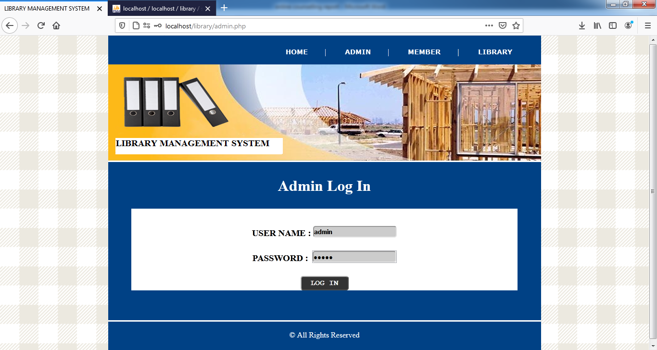

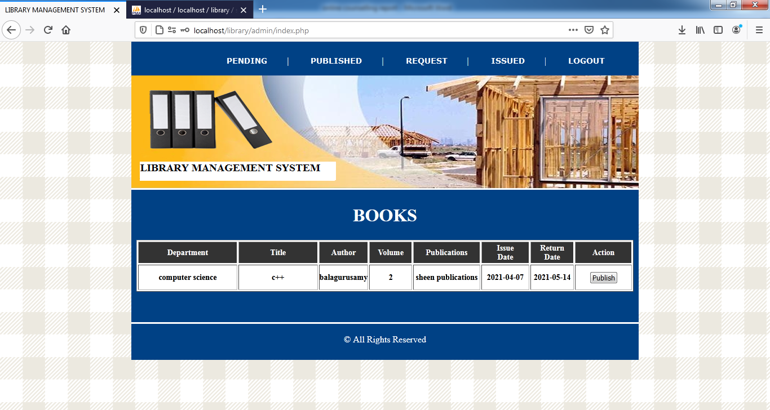

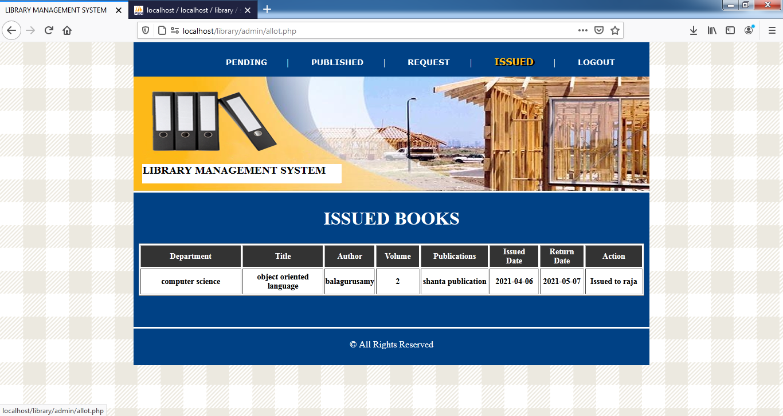

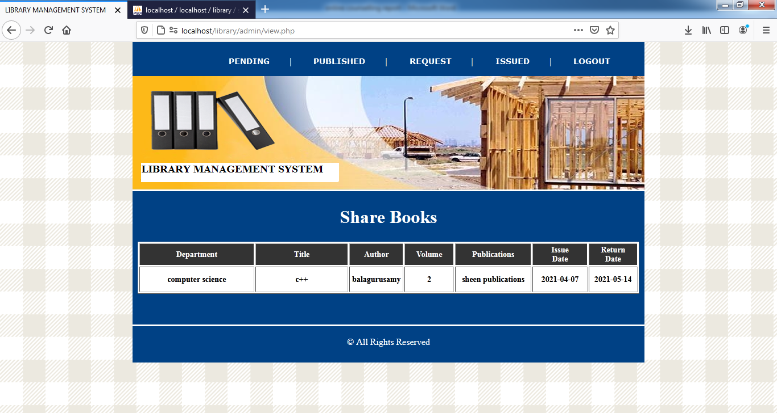

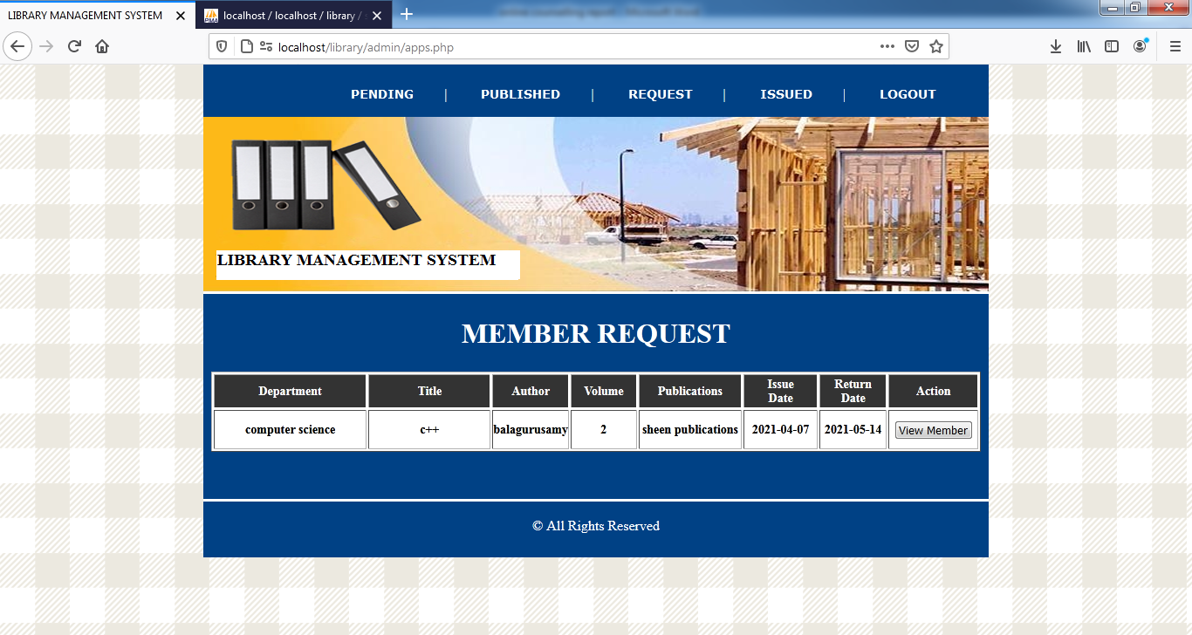

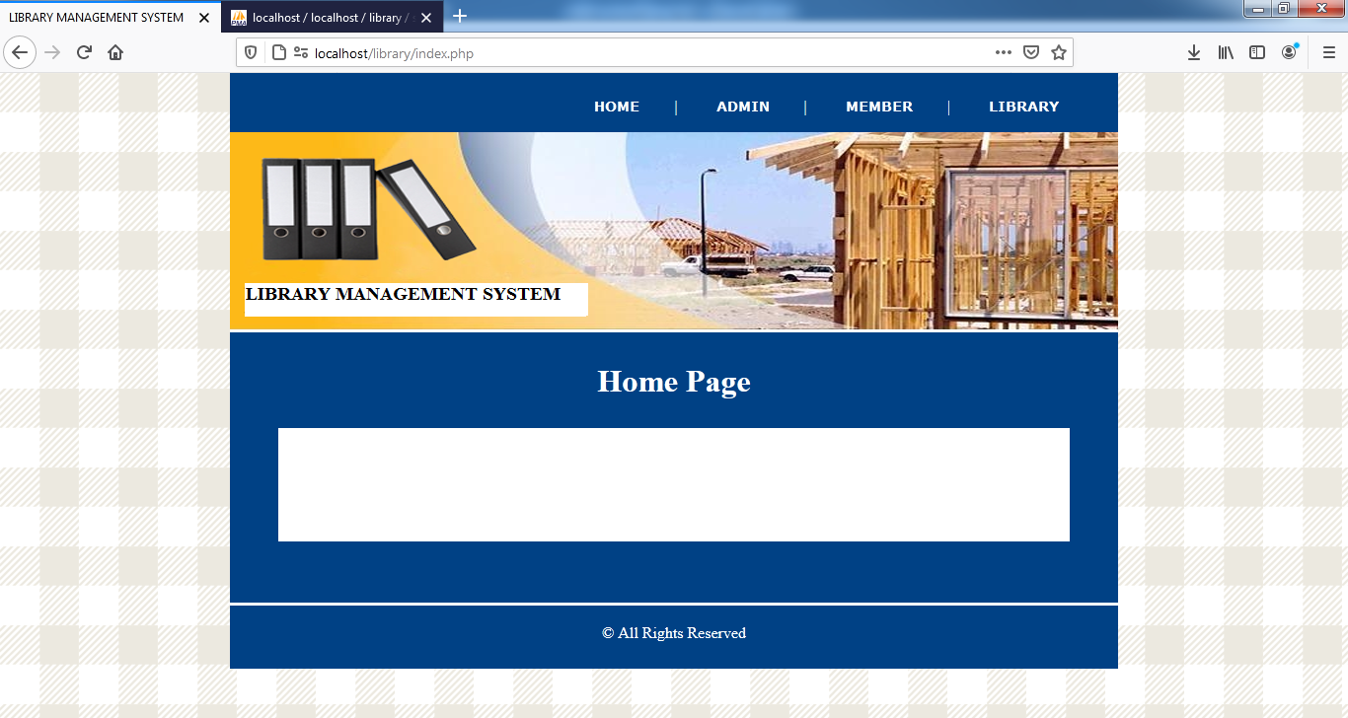

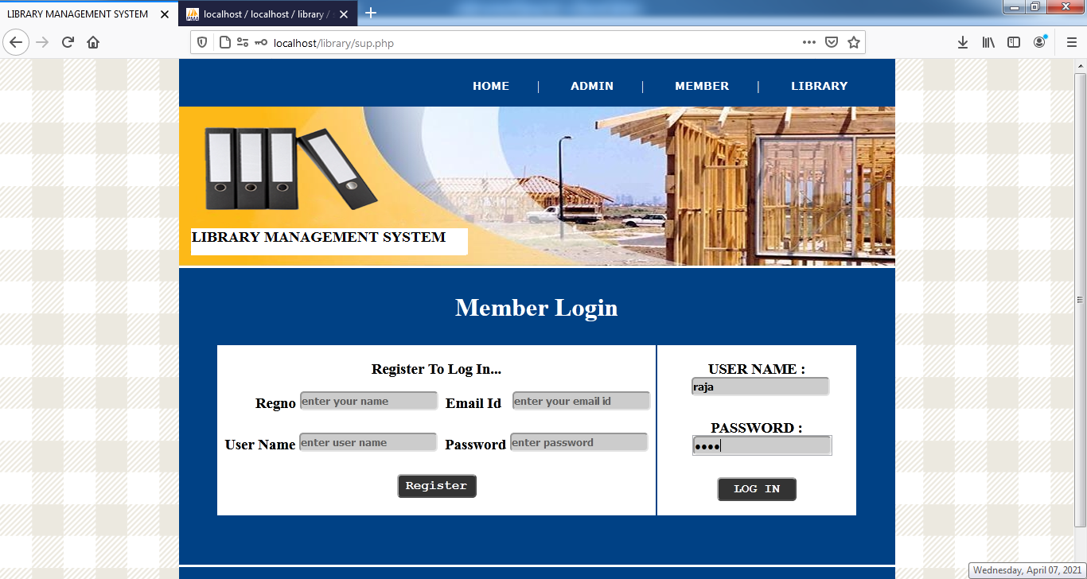

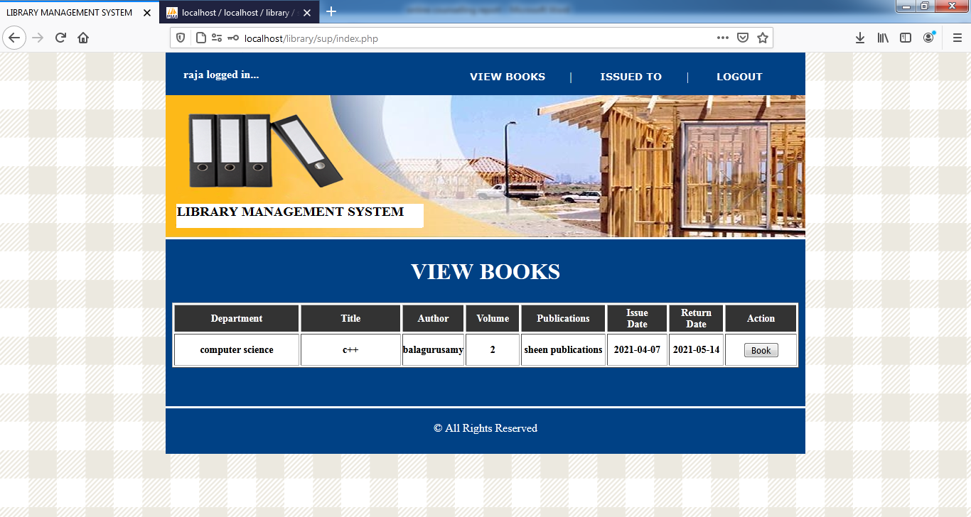

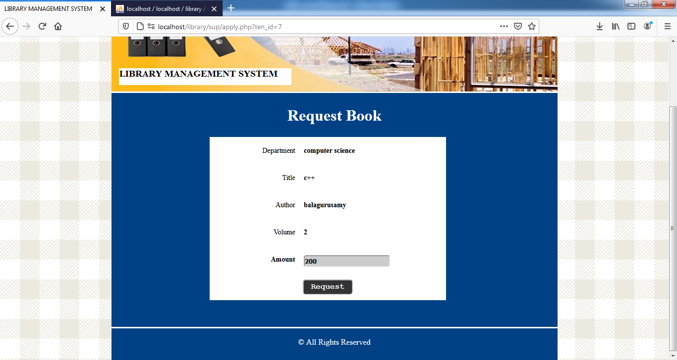

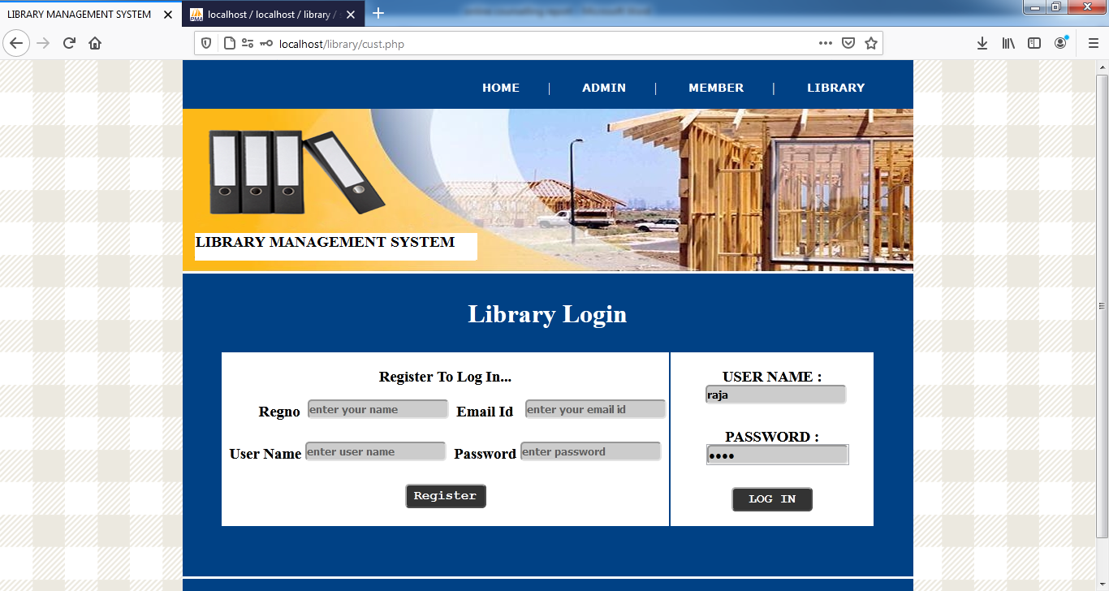

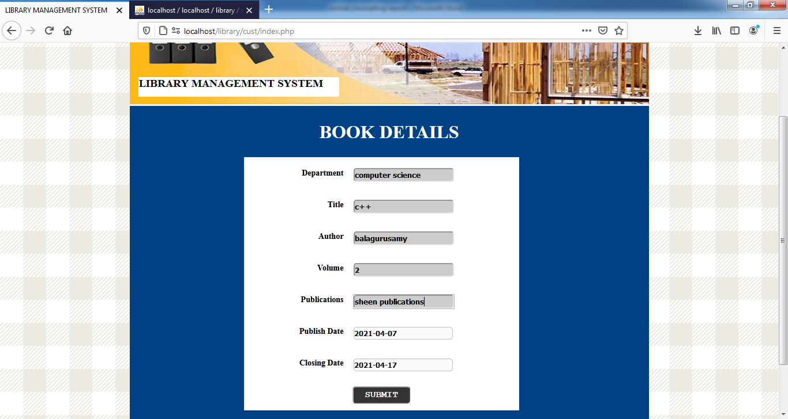

SAMPLE OUTPUT

